DATA ANALYSIS PROJECT REPORT
Women's Clothing
Trends and Analysis in the Fashion Industry
Univariate Analysis of Numerical Features
Prepared by | Harsh Panchal
Dataset | Women's Clothing E-Commerce Reviews
Analysis scope | Histogram, Boxplot, KDE, Skewness, Kurtosis and Transformation
August 2026

Executive Summary
This report presents a univariate analysis of the numerical features in the Women's Clothing E-Commerce Reviews dataset. The analysis uses custom visualization and statistical functions to study each variable independently through histograms, boxplots, kernel density estimation (KDE), skewness, kurtosis, and IQR-based potential outlier detection.
The dataset contains 23,486 observations and 11 original columns. After excluding the saved index, the identifier field, and the binary recommendation indicator, three numerical features were selected: Age, Rating, and Positive Feedback Count. The results show mild positive skew in Age, strong negative skew in Rating because most customers gave high scores, and extreme positive skew in Positive Feedback Count. A log1p transformation reduced feedback skewness from 6.4730 to 1.0872.
Main conclusion: Age can remain unchanged, Rating should remain in its original ordinal scale, and Positive Feedback Count should use the added log1p feature when a model benefits from reduced skewness.

1. Project Introduction
Fashion e-commerce platforms generate numerical and textual customer-review data. Before modeling or advanced analysis, the distribution of each numerical feature must be understood. Univariate analysis reveals central tendency, spread, asymmetry, tail behaviour, and potential extreme values. These properties influence the selection of transformations and the interpretation of later statistical or machine-learning results.

2. Objectives
1 | Automatically identify valid numerical features for distribution analysis.
2 | Implement reusable functions for histograms, boxplots, and KDE plots.
3 | Calculate descriptive statistics, skewness, kurtosis, and IQR outliers.
4 | Interpret the distribution of each selected numerical column.
5 | Identify and evaluate a suitable transformation where required.

3. Dataset Overview
Rows | Original columns | Selected numerical columns | Missing values in selected columns
23,486 | 11 | 3 | 0
Clothing ID was excluded because it identifies products rather than measuring a continuous characteristic. Recommended IND was excluded because it contains only 0 and 1 and is therefore binary categorical data. The Unnamed: 0 field was removed because it was only a saved row index.

4. Methodology
Technique | Purpose | Interpretation
Histogram | Shows frequencies across value ranges. | Reveals peaks, gaps, concentration and asymmetry.
Boxplot | Summarizes quartiles, median and IQR. | Flags values beyond 1.5 x IQR as potential outliers.
KDE plot | Creates a smooth estimate of distribution shape. | Supports visual comparison of density and skewness.
Skewness | Measures distribution asymmetry. | Negative = left skew; positive = right skew.
Kurtosis | Measures excess tail weight relative to normal. | High positive values suggest heavy tails/extremes.

4.1 Statistical Rules
Potential outliers were detected with the interquartile range rule: values below Q1 - 1.5 x IQR or above Q3 + 1.5 x IQR were flagged. These points were not automatically deleted because a statistical flag does not prove that a value is incorrect.
Skewness range | Classification | Typical action
-0.5 to 0.5 | Approximately symmetric | Usually no transformation
0.5 to 1.0 | Moderate right skew | Optional square-root transform
> 1.0 | Strong right skew | Consider log1p for non-negative values
-1.0 to -0.5 | Moderate left skew | Inspect scale and measurement type
< -1.0 | Strong left skew | Consider Yeo-Johnson if continuous

4.2 Custom Function Workflow
For every selected column, the custom function removed missing values only for that column, calculated descriptive statistics, applied the IQR rule, generated three plots, interpreted skewness and kurtosis, and returned a structured record. The returned records were combined into one summary table, ensuring consistent analysis across columns.

5. Results and Interpretation

5.1 Age
Mean | Median | Std. dev. | Range | Skewness | Outliers
43.20 | 41.00 | 12.28 | 18-99 | 0.5256 | 109 (0.46%)
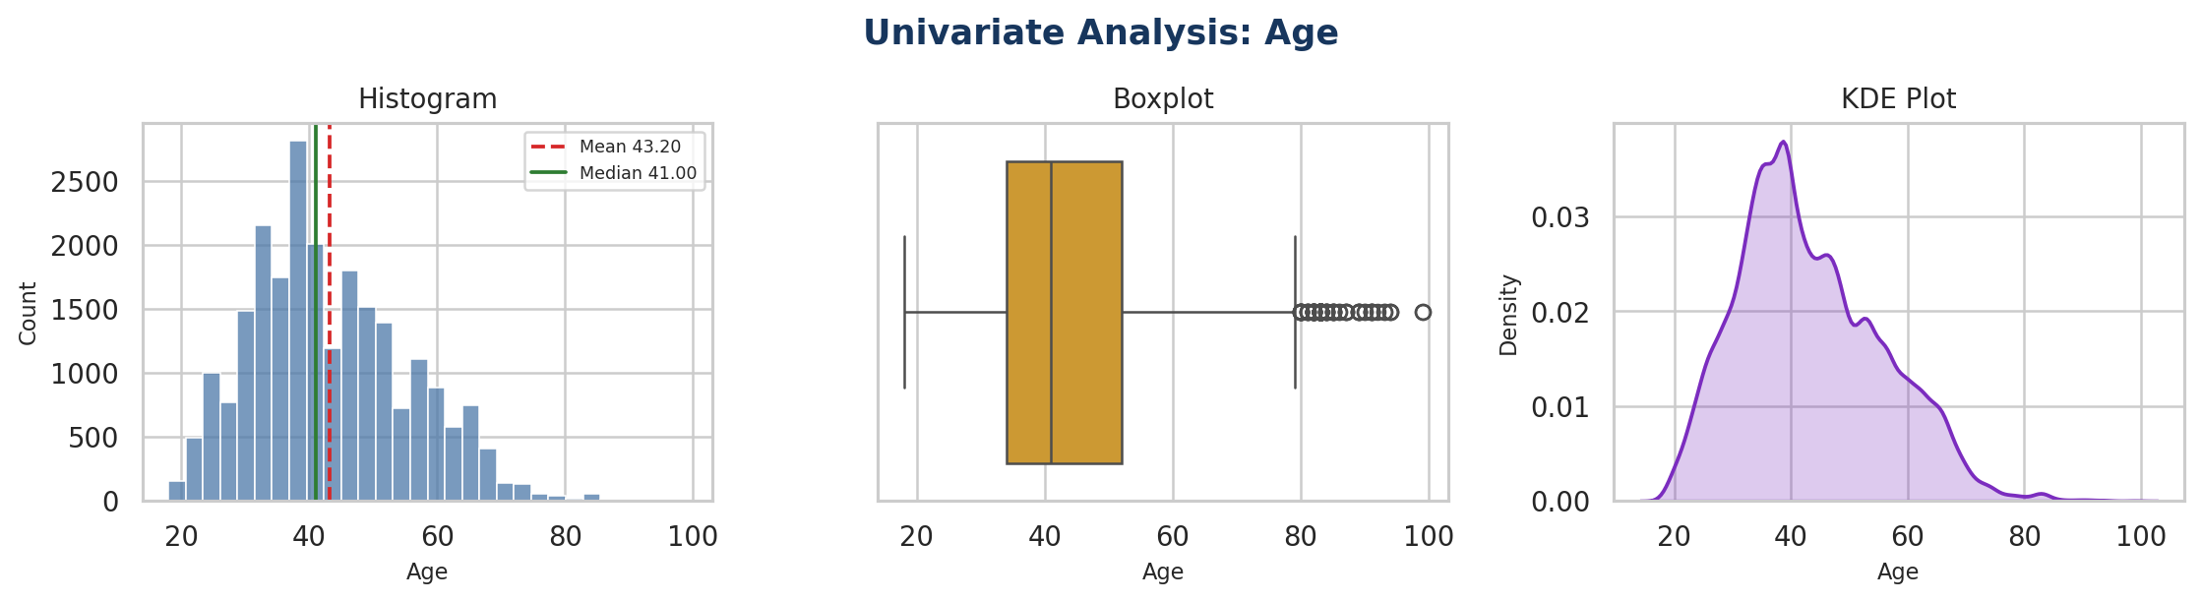
Figure 1. Histogram, boxplot and KDE plot for Age.
Age is moderately positively skewed (0.5256). The mean is slightly higher than the median, matching the longer right tail visible in the histogram and KDE plot. Only 109 observations, or 0.46%, are flagged by the IQR rule. The distribution is sufficiently stable for exploratory work, so transformation is optional rather than necessary.
Decision: Retain Age in its original scale. A square-root transformation may be tested only if a later model shows sensitivity to mild skewness.

5.2 Rating
Mean | Median | Std. dev. | Range | Skewness | IQR flags
4.20 | 5.00 | 1.11 | 1-5 | -1.3135 | 2407 (10.25%)
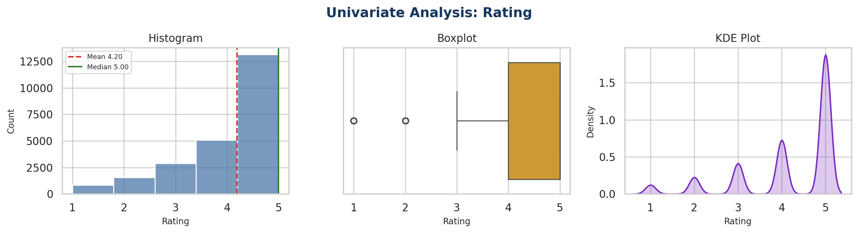
Figure 2. Histogram, boxplot and KDE plot for Rating.
Rating is highly negatively skewed (-1.3135) because most reviews have ratings of 4 or 5. The median is 5 and the mean is 4.20, indicating strong concentration at the upper end. Although the IQR rule flags ratings of 1 and 2, these are valid responses on the defined five-point scale and must not be treated as data errors.
Decision: Do not transform Rating and do not remove low ratings. Rating is an ordinal feature with five valid levels, so preserving its original meaning is more important than forcing normality.

5.3 Positive Feedback Count
Mean | Median | Std. dev. | Range | Skewness | Outliers
2.54 | 1.00 | 5.70 | 0-122 | 6.4730 | 2147 (9.14%)
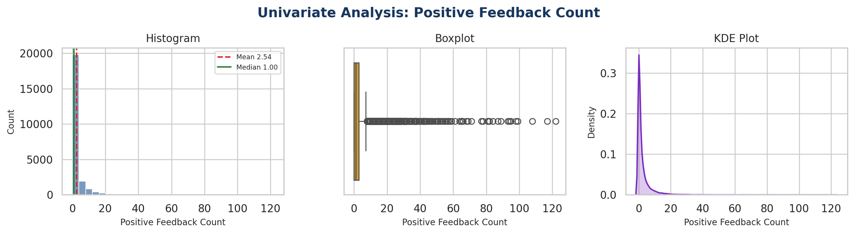
Figure 3. Histogram, boxplot and KDE plot for Positive Feedback Count.
Positive Feedback Count is extremely right-skewed (6.4730) with very high excess kurtosis (71.6932). Most reviews have little or no positive feedback, while a small number reach values as high as 122. The 2,147 IQR flags represent 9.14% of observations. These values may reflect genuinely popular reviews and should not be deleted automatically.
Decision: Create an additional log1p-transformed feature to reduce skewness while keeping the original count column for interpretation.

6. Transformation Analysis
The natural logarithm cannot be directly applied to zero. Therefore, the transformation log(1 + x), implemented as numpy.log1p, was used for Positive Feedback Count. It preserves zero and compresses large counts more strongly than small counts.
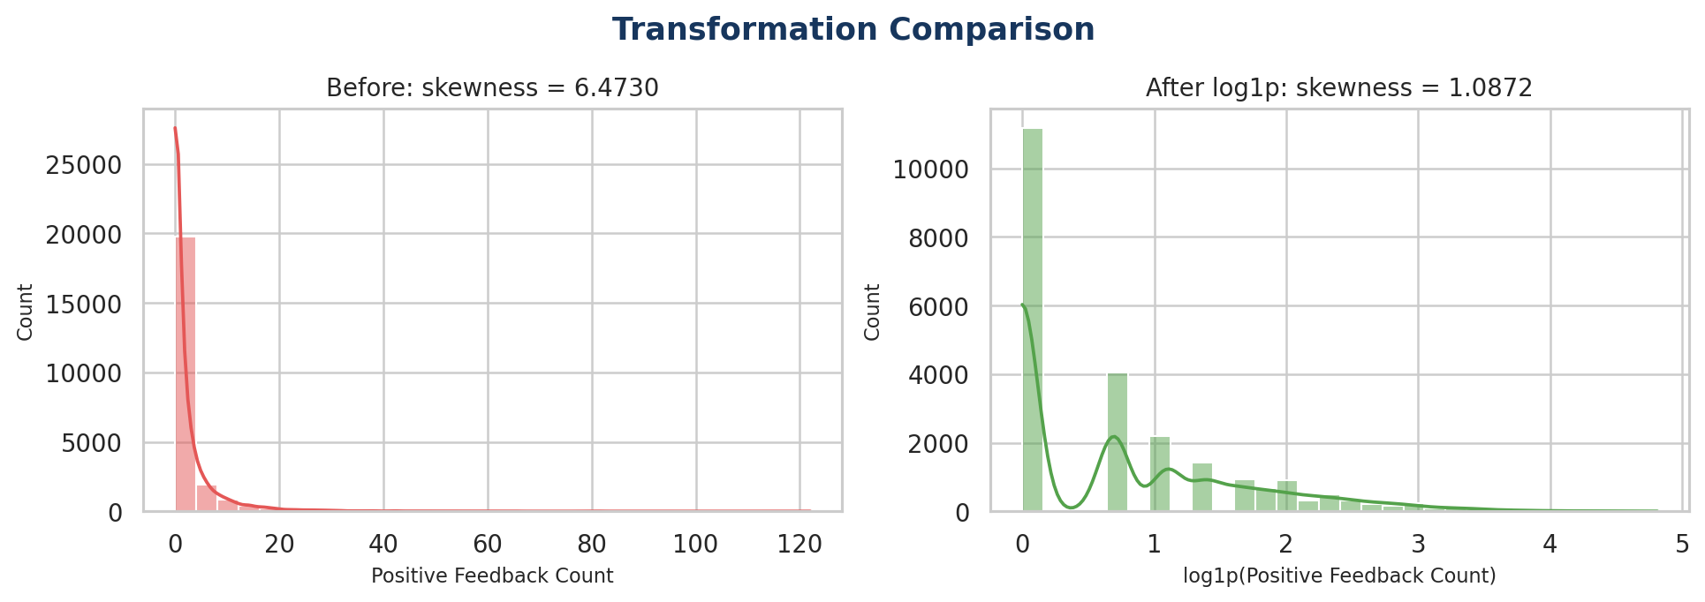
Figure 4. Positive Feedback Count before and after log1p transformation.
Feature | Method | Original skewness | Transformed skewness
Positive Feedback Count | log1p | 6.4730 | 1.0872
The transformation reduced skewness from 6.4730 to 1.0872, a substantial improvement. The transformed feature remains somewhat right-skewed because the original variable is discrete, zero-heavy count data. Perfect normality is neither expected nor required; the objective is to reduce the dominance of extreme values while preserving ordering.

7. Final Summary
Column | Skewness | Kurtosis | Distribution | Final action
Age | 0.5256 | -0.1118 | Moderate right skew | Keep original; sqrt optional
Rating | -1.3135 | 0.8041 | Strong left skew | Keep ordinal scale
Positive Feedback Count | 6.4730 | 71.6932 | Extreme right skew/heavy tail | Add log1p feature

8. Conclusion
The project successfully implemented a consistent, reusable univariate-analysis workflow for numerical features. The custom function produced histograms, boxplots, KDE plots, skewness and kurtosis values, IQR-based flags, interpretations, and transformation recommendations. Age showed only mild asymmetry, while Rating was strongly concentrated at high scores but should remain unchanged because it is ordinal. Positive Feedback Count required treatment because of extreme right skew and heavy tails; log1p substantially improved its distribution.
The processed dataset retains the original variables and adds Positive Feedback Count_log1p. This preserves interpretability while providing a more model-friendly representation for future correlation analysis, feature scaling, regression, classification, or customer-review trend modeling.

9. Project Outputs
Output file | Purpose
univariate_analysis_summary.csv | Column-level statistics, distribution labels and recommendations.
womens_clothing_univariate_processed.csv | Dataset containing the added log1p-transformed feedback feature.
transformation_comparison.csv | Before-and-after skewness comparison for transformed variables.

